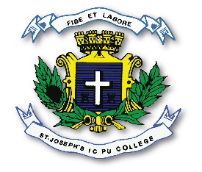
ST. JOSEPH’S INDIAN COMPOSITE PU COLLEGE
#23, Vittal Mallya Road, Bangalore – 560001.

SUBJECT: ENGLISH (02)
I PUC
PORTIONS FOR I TEST – 2023-24
Text Book - 1. The Gentlemen of the Jungle.
2. The School Boy.
3. Around a Medicinal Creeper
4. Oru Manushyan

Grammar - Articles, Preposition, Verbs, Subject-Verb
Agreement, Correction of sentences, Word Order,
Comprehension Passage

